interconnectedness: the inclusion of other in the self scale (ios)

choose the number or half number that best describes how connected you feel right now with the other person:
2.5
1.5
3.5
1
2
3
4

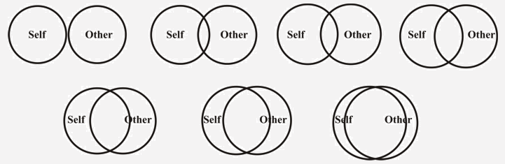
4.5
5.5
6.5
6
5
7

Aron, A., et al. (1992). "Inclusion of Other in the Self Scale and the structure of interpersonal closeness." Journal of Personality and Social Psychology 63(4): 596-612. In 2 studies, the Inclusion of Other in the Self (IOS) Scale, a single-item, pictorial measure of closeness, demonstrated alternate-form and test–retest reliability; convergent validity with the Relationship Closeness Inventory (E. Berscheid et al, 1989), the R. J. Sternberg (1988) Intimacy Scale, and other measures; discriminant validity; minimal social desirability correlations; and predictive validity for whether romantic relationships were intact 3 mo later. Also identified and cross-validated were (1) a 2-factor closeness model (Feeling Close and Behaving Close) and (2) longevity–closeness correlations that were small for women vs moderately positive for men. Five supplementary studies showed convergent and construct validity with marital satisfaction & commitment and with a reaction-time (RT)-based cognitive measure of closeness in married couples; and with intimacy and attraction measures in stranger dyads following laboratory closeness-generating tasks. In 3 final studies most Ss interpreted IOS Scale diagrams as depicting interconnectedness.

Gächter, S., et al. (2015). "Measuring the closeness of relationships: A comprehensive evaluation of the 'Inclusion of the Other in the Self' scale." PLoS ONE 10(6): e0129478. (Available in free full text) Understanding the nature and influence of social relationships is of increasing interest to behavioral economists, and behavioral scientists more generally. In turn, this creates a need for tractable, and reliable, tools for measuring fundamental aspects of social relationships. We provide a comprehensive evaluation of the 'Inclusion of the Other in the Self' (IOS) Scale, a handy pictorial tool for measuring the subjectively perceived closeness of a relationship. The tool is highly portable, very easy for subjects to understand and takes less than 1 minute to administer. Across our three online studies with a diverse adult population (n = 772) we show that six different scales designed to measure relationship closeness are all highly significantly positively correlated with the IOS Scale. We then conduct a Principal Component Analysis to construct an Index of Relationship Closeness and find that it correlates very strongly (ρ = 85) with the IOS Scale. We conclude that the IOS Scale is a psychologically meaningful and highly reliable measure of the subjective closeness of relationships.

